Data Analyst for Retailer App Case Study

1. Prepare a report regarding our growth between the 2 years. Please try to answer the following questions:

a. Did our business grow?

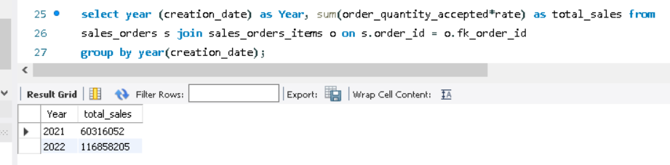

**On basis of yearly sales there is business growth in year 2022 as compared to 2021. We can clearly notice difference using chart.**

b. Does our app perform better now?

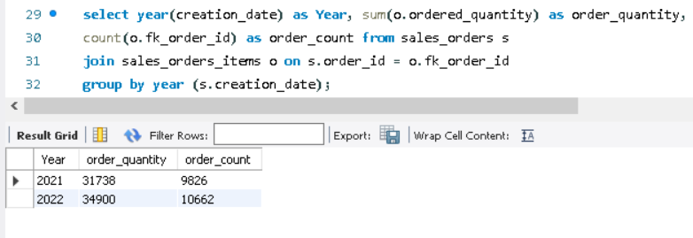

**On basis of order count and order quantity we conclude that there is visible increment and our app performance grown in 2022.**

c. Did our user base grow?

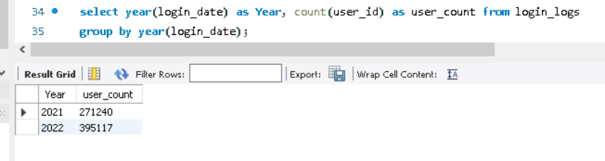

**Our user base was 41% in 2021 and it grown up by 18% in 2022.**

3. What are our top-selling products in each of the two years? Can you draw some insight from this?

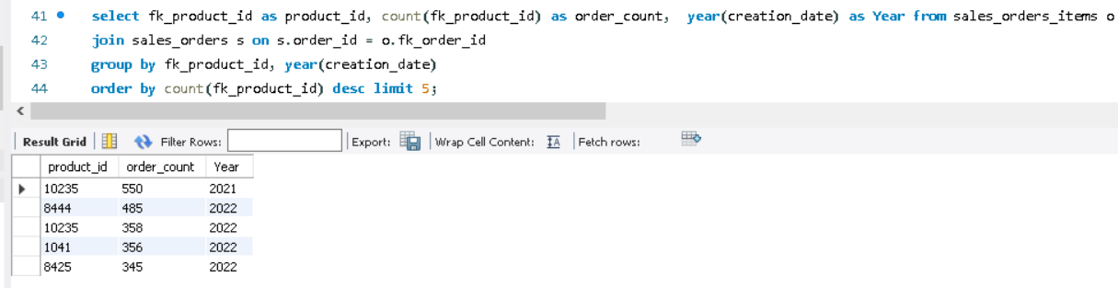

* **10235 is topmost selling product between 2 years having 550 orders placed in 2021.**
* **For year 2022 product 8444 is top selling product.**

4. Looking at July 2021 data, what do you think is our biggest problem and how would you recommend fixing it?

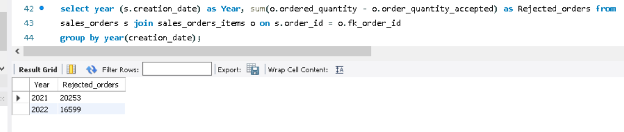

**Rejected orders in 2021 are more and that is the biggest problem of that year.**

* **To fix it we can check the reasons like product quality, insufficient margin.**
* **We should check customer satisfaction for orders delivered.**
* **Always keep stock available which leads to late delivery and order cancellation.**
* **Process shipment on time.**

**By checking these points we can reduce the order rejection.**

5. Does the login frequency affect the number of orders made?

**Average login time of the customers per year:**

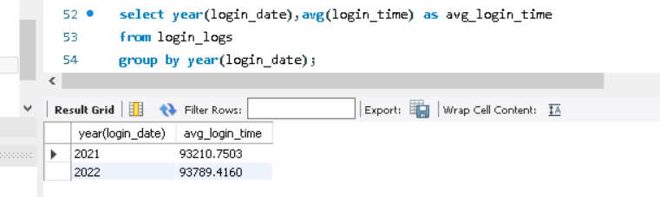

**Average order creation time of the customers per year:**

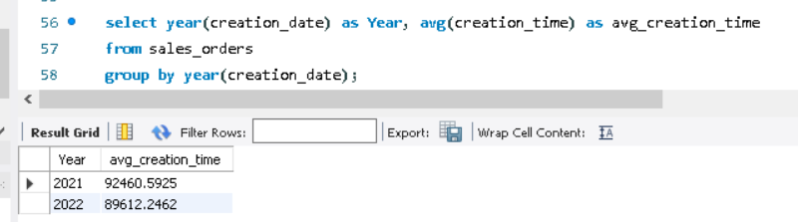

**Average login time was increased from 2021 to 2022 but still average order creation time is decreased, so I can conclude that they do not depend each other.**